Power Circuit

Three phase motor connected to full-voltage reversing starter controlled by stop forward and reverse push button station

TASK 4

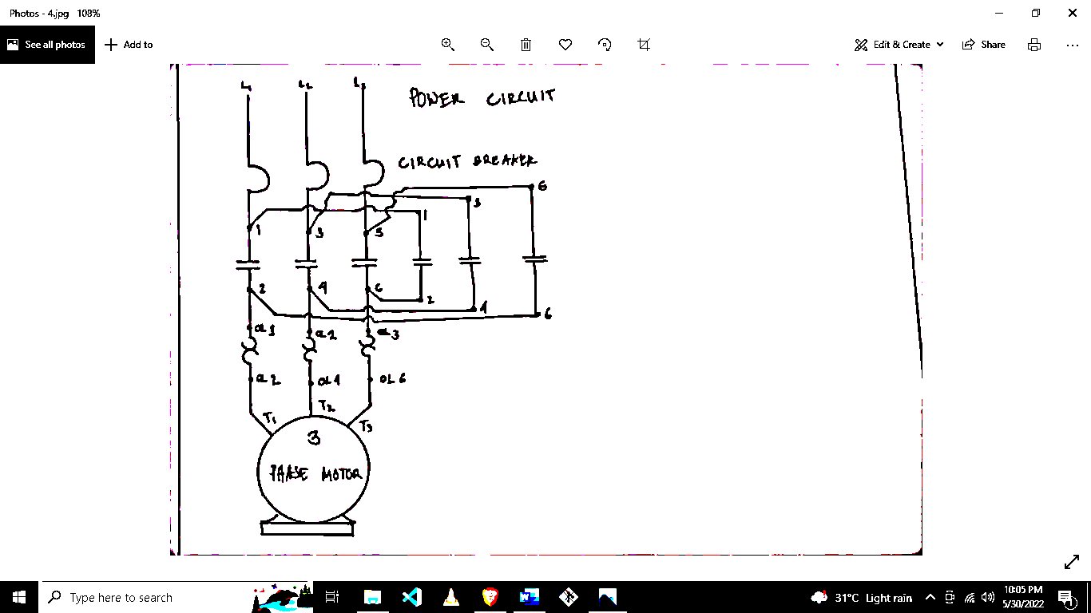

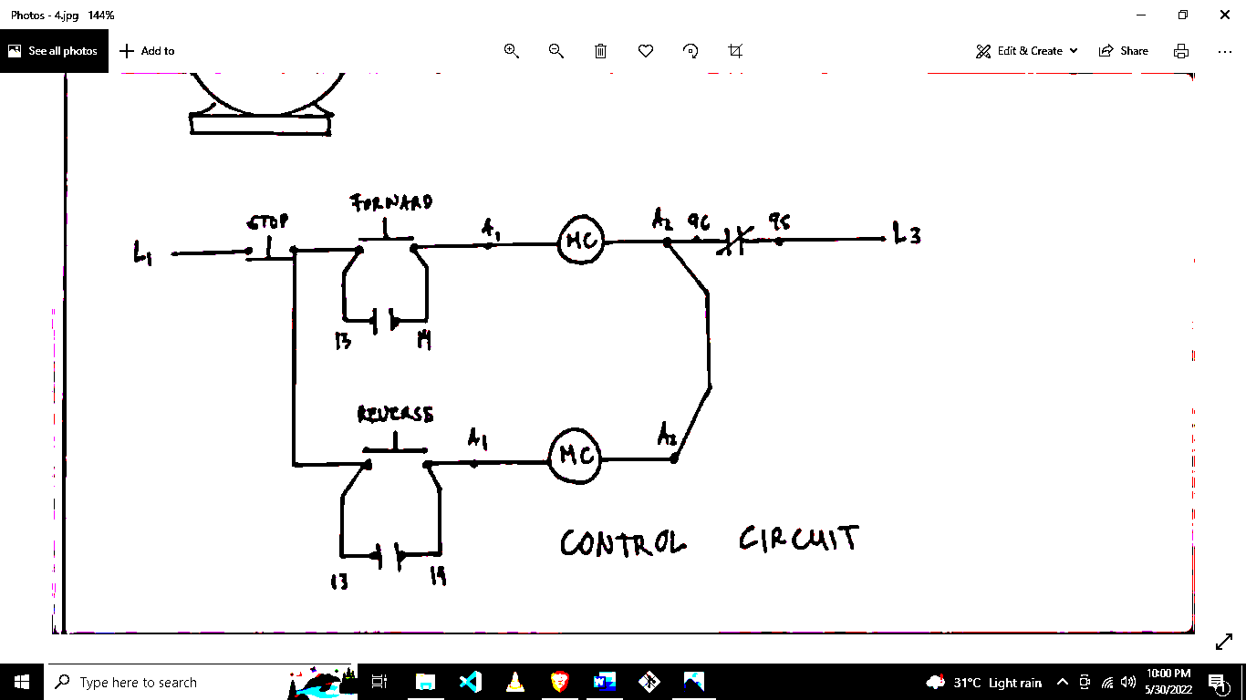

Control Circuit